
MIZAN_TEPI UNIVERSITY

School of Computing & Informatics
DEPARTEMENT OF Inoformation technology
fundamental of database management system
Assignment Title: MTU Students cafeteria
Type: Group Assignment Prepared by G-5
S/N | Students Names | ID No.
 | HABTAMU ADISU | MTUUR/7837/17
 | DANIEL CHAMASA | MTUUR/8881/17
 | AMLAKU TADELE | MTUUR/8849/17
 | EFREM DACHEW | MTUUR/8928/17
 | FENET TAREKEGN | MTUUR/8387/17

Submitted to Instructor: MR. BIRHANU
Submission date: 12, January , 2026 G.C.
📍 Ethiopia – Mizan-TEpi Campus
Table of Contents
Acknowledgment ii
1. Introduction 1
2. Background 2.
2.1. Mission 2.
2.2. Vision 3.
3. Analaysis of the current cafeteria system. 3.
3.1. overview of the manual system 3.
3.2 critical challenges 4.
4. The Proposed digital solution 4.
5. Project Objectives 4.
5.1. General objectives 4.
5.2. Specific objectives 5.
6. Project Scope 5.
7.Project Design The new system 5'
8. ER DIAGRAM 8
9. EER DIAGRAM 9
10. DATA DICTIONARY FOR ENTITY ATTRIBUTES 11
11. NORMALIZATION 15
12. SQL IMPLEMENTATION 17

List of Figure
Figure 1. ER diagram for students cafeteria 8
Figure 2 EER diagram for students cafeteria 9
Figure 3 Schema Maping for Students Cafeteria Entity Table 14

List of Table
Table 1 Table for student records 11
Table 2 Table for worker records 12
Table 3 Table for manager records 12
Table 4 Table for dependent records (weak entity tied to worker) 13
Table 5 Table for cafeteria details 13
Table 6 Table for supplier company details (note: spelling corrected from Suplier Campany) 13
Table 7 Table for security personnel details 14

Acknowledgment

In this section, we would like to express our sincere gratitude to everyone who supported us in initiating and completing this project. We are deeply thankful to all who dedicated their time and effort to guide us toward its successful completion.

First and foremost, we extend our heartfelt appreciation to our database instructor, Mr.birhanu for granting us permission to work on the title of our interest and for his invaluable guidance from the very beginning up to the completion of this project.

1.Introduction
Today all activities of human being throughout the world becomes operated with the help of computer. This computerized dealing with data enables peoples to become productive and secure on their work. The main issue of those peoples are how to store and how to access those data in a simple and reliable way. In this project we are going to deal with this issue mainly we revolve on the area Mizan Tepi University Students Cafeteria. There are two types of data handling approach which are practiced in most of small up to large institutions in the current context. Those approaches are the traditional data handling in which data are stored on piece of paper and cards in which it makes difficult to users in order to access, retrieve, update and modify data since there is higher duplication of datas on the papers for every separate records. This system is very less secured system in which datas are stored on papers and cards and it is also difficult to store a large amount of data like in universities and other higher organizations. In order to avoid this difficulties there is the second type of data handling approach which is a database approach data handling which is the way of dealing with data using computer with the help of a general purpose software DBMS which is suitable to deal with a huge data. So in this project we are going to identifying problem in the data handling of our institution students cafeteria and we will design solution to it.
So, in this project we will study how to develop a new advanced data handling system for our cafeteria and we will design a data base data handling approach to the cafeteria to enable the cafeteria to maintain data and to handle students information in proper and secure way. The main purpose of our project is to change the current data handling system that is traditional file based approach to the newly implemented database approach. Our project also wants to understand the data modeling concepts that is used in a real time scenario and to implement a fully functional database system which interacts with a front-end interface.

Background

Mizan-Tepi University (MTU) is a prominent Ethiopian higher education institution located in the South West Ethiopia Peoples' Region. The university operates across three specialized campuses:

 Mizan Campus: Located in Mizan Aman town, approximately 610 km from Addis Ababa.

 Aman Health Campus: Situated near the Aman Airport, focusing on medical and health sciences.

 Tepi Campus: Located in Tepi town, roughly 690 km from the capital.

The Tepi Campus infrastructure includes dedicated facilities to support student life, featuring two student cafeterias, a student lounge, and a staff lounge, all designed to foster a supportive campus community.

2.1. Mission

The primary mission of the Mizan-Tepi University cafeteria service is to support the academic excellence of our students. We believe that nutritional well-being is a cornerstone of cognitive success. By providing high-quality, balanced meals in a hygienic and welcoming environment, we empower students to focus on their studies and achieve their full potential.

Core Responsibilities and Activities:

To fulfill this mission, the cafeteria management undertakes the following:

1. Digital Enrollment: Maintaining an accurate registry of students within the cafeteria management system.

2. Meal Tracking: Monitoring daily meal distribution to ensure fair and efficient service.

3. Supply Chain Management: Rigorously recording and inspecting all ingredients and items received from suppliers to ensure quality.

4. Nutritional Service: Preparing and serving diverse, healthy food options.

5. Administrative Synchronization: Cross-checking student eligibility with the University Registrars records.

6. Financial Accountability: Computing student cost-sharing data and managing budget allocations.

7. Performance Analytics: Generating daily operational reports to identify areas for improvement.

2.2. Vision

Our vision is to transform the traditional dining experience into a smart, student-centric culinary service. We aspire to:

 Digital Transformation: Transition from manual processes to a fully integrated, technology-driven management system (e.g., biometric or card-based access).

 Institutional Leadership: Become a benchmark for cafeteria services within Ethiopian higher education through innovation and efficiency.

 Holistic Health: Foster a healthier generation by prioritizing food safety and nutritional education.

 Community & Stability: Create a peaceful, inclusive dining environment that serves as a model of harmony for the entire university.

 Operational Excellence: Implement sustainable practices that reduce waste and lower costs while maximizing the quality of the student experience.

3. Analysis of the Current Cafeteria System
3.1. Overview of the Manual System
Currently, the Mizan-Tepi University student cafeteria relies on a traditional, paper-based data handling system. Information is recorded manually on paper and physical cards, which creates significant barriers to efficient data access and cross-departmental sharing. This manual approach is highly susceptible to physical wear and tear, leading to the potential loss of vital records.
3.2. Critical Challenges
The reliance on a manual system has introduced several operational bottlenecks:
 Information Silos: It is difficult to share real-time updates with students, management, and external suppliers.
 Data Redundancy: Frequent duplication of information across different files leads to inconsistencies.
 Storage & Security Risks: Physical records require significant space and are vulnerable to loss, unauthorized access, or destruction.
 Administrative Friction: Managing student recordsspecifically adding new students or updating existing informationis labor-intensive and slow.
 Financial Impact: These inefficiencies result in financial leakage and overall customer dissatisfaction.
4. The Proposed Digital Solution
We propose a modern Client-Server Database System designed to centralize cafeteria operations across all three campuses (Mizan, Tepi, and Amman).
Key Features of the New System:
 Centralized Database: All participant dataincluding IDs, contact details, and roleswill be stored in a secure, unified database.
 Secure Access: Role-based access control will allow authorized users to interact with the data using unique credentials.
 Efficiency: The system will utilize a structured query language to update, retrieve, and manage data instantly.
 Inter-Campus Connectivity: An online connection will ensure that data is synchronized across all three campus locations.
Up5. Project Objectives
5.1. General Objective
The primary goal of this study is to transition Mizan-Tepi University from a vulnerable, paper-based system to a robust, computerized Database Management System (DBMS) to streamline cafeteria operations across all campuses.
5.2. Specific Objectives
To achieve this digital transformation, the project will focus on:
 System Analysis: Identifying the specific weaknesses of the current manual process.
 Requirements Gathering: Defining the essential entities and relationships within the cafeteria ecosystem.
 Data Modeling: Designing and building a specialized database model using Entity-Relationship (ER) and Enhanced Entity-Relationship (EER) diagrams.
 Functionality: Implementing features for seamless data retrieval, deletion, and updates via query languages.
 Reporting: Enabling the generation of accurate, automated reports for management.
6. Project Scope
This project is dedicated to the comprehensive overhaul of the data management system for Mizan-Tepi Universitys cafeterias. Once implemented, the system will serve as the primary administrative tool for students, staff, and managers at the Mizan, Tepi, and Amman campuses. By centralizing information, we aim to foster a collaborative environment where all stakeholders work from a "single source of truth," eliminating the errors of the past.

7.Project Design The New System
In this process we use the following different steps to design our database for our project
Step 1: Requirements Collection and Analysis
In this study we try to collect data from the student cafeteria and we understand the overall problems within the cafeteria and we can get the following outputs from this step.
      - Students want a system which enables them to view their information in the cafeteria such as cost sharing using their PC and smart phone with help of web based connection.
      - Workers want to have a system which enable them to record and store their data easily.
      - Managers want a system which can enable them to report daily works to the higher level with faster and secure way.
      - All the actors in the cafeteria are identified.
      - Generally, in this step we able to identify what problem is there in the cafeteria and what the actors and users want.
Step 2: Conceptual Database Design
In this step the actual participants and relationship among them is identified and higher level conceptual data model is drawn as ER. In order to perform this activity first we should have to understand the following terms first since they are the major parts of this step.
The Entity Relationship describes data as entities, relationships and attributes in a system and in the data base.
Entity the basic object that the ER represents which is a "thing" in the real world with an independent existence. In our study we have two types of entities.
- Those are entities with physical existence which includes cafeteria workers, manager, students and food.
- The other are those entities which are with a Conceptual existence those entity includes a supplier company and the cafeteria.
Attributes are the particular properties that describe an entity.
In our study we have the following entities and their respective attributes.
- Cafeteria workers entity is described by the attributes such as workers name, age, address, salary, and job.
- Managers: described by the attributes such as address, Ssn and phone number.
- Supplier companies: described by the attributes such as location, company name, establishment date.
- Cafeteria: described by the attributes such as establishment date, location, name, working hours.
- Food: described by the attributes such as name, type, quantity, price and
- Students: described by the attributes such as Sid, name, dormitory, department, age.
A particular entity will have a value for each of its attributes. The attribute values that describe each entity become a major part of the data stored in our cafeteria database.
For example: cafeteria have
Name: MTU students cafeteria.
Establishment date: 1999 Ec.
Location: in Tepi campus ten meters from door.
- Relationship: is an association between different entity or (between different instances of the same entity).
In our study we have the following relationship
Example: food provided to students. In this case provided to is a relation describe association between two entities food and students and the other relations in our system are work for, has and manage.
Figure 1. ER diagram for students cafeteria

8.ER DIAGRAM
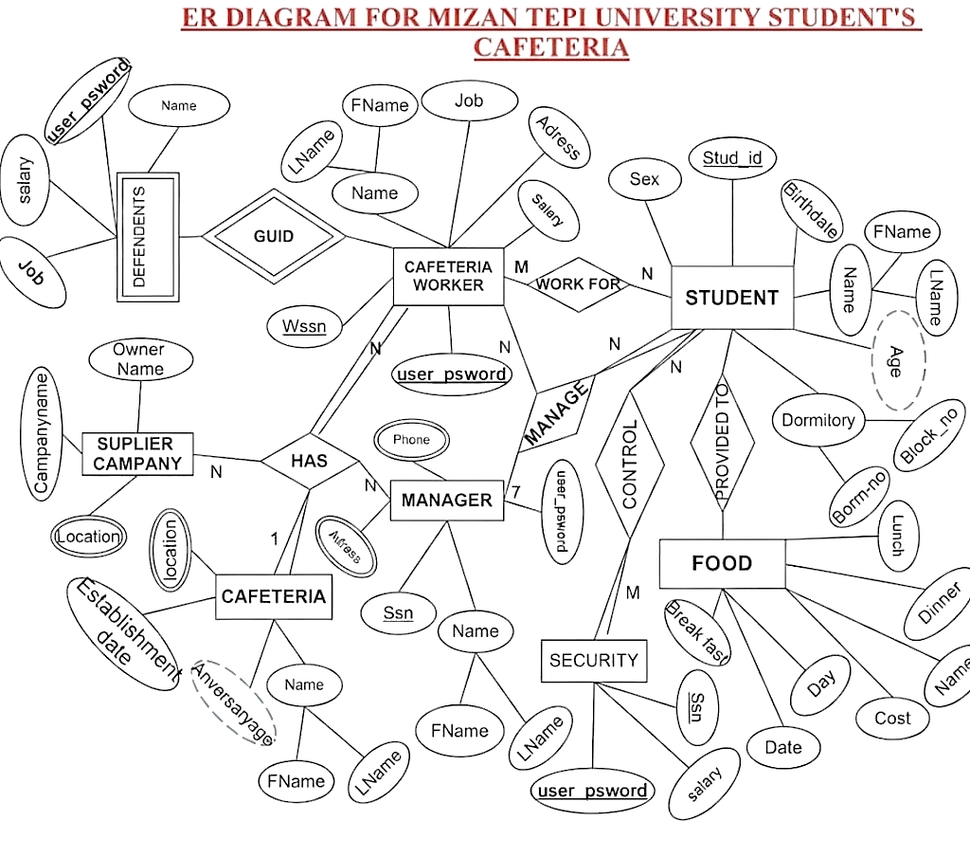

Figure 1.ER diagram for students cafeteria

9.EER DIAGRAM
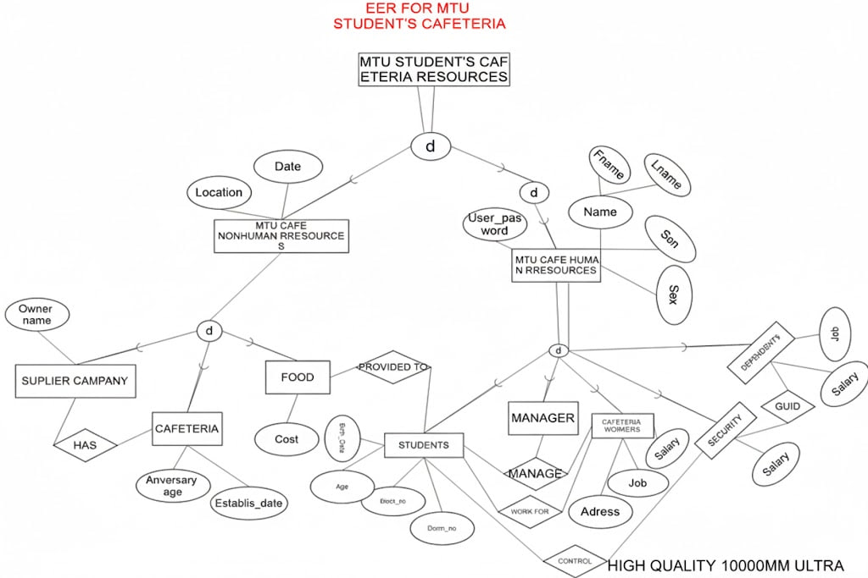

Figure 2 EER diagram for students cafeteria

Step 3: Logical Database Design
In this step we prepare the schema diagram for the data base we will use
Student
Sid | Fname | Lname | Batch | Sex | B_date | Age | Blockno | Dormno

Cafeteria Workers
Wssn | Fname | Lname | Address | Sex | Salary | Work_hr

Manager
Ssn | Wssn | Sid | Fname | Lname | Address | Pho_no | Salary

Dependents
Wssn | Salary | Job

Cafeteria
Name | Location | Work_hr | Establish_t Date | Anversary_age

Suplier campany
Owner name | Campany name | Location | Establish_t Date

Security
Wssn | Sid | Address | Salary

Food
Name | Type | Quantity | Cost

10.DATA DICTIONARY FOR ENTITY ATTRIBUTES
After designing the schema diagram we prepare a data dictionary as follow for every entities with respect to their attributes which is to be stored in the database we are going to design.

DATA DICTIONARY FOR STUDENT ENTITY
Attributes | Data type & Domain | Key and Discription
Sid | varchar (10) | Primary key not to be NULL
Fname | Varchar(20) | The name of the student
Lname | Varchar(30) | The name of students father
Batch | Integer(int) | The year stayed in the university
Sex | Varchar(2) | Either of male as M and female F
B_date | Int | The students birth date
Age | Int | Derived value from the birth date
Blockno | Int | The block no the student live in
Dormno | Int | The dorm no the student live in
Table 1 Table for student records
DATA DICTIONARY FOR WORKER ENTITY
Attributes | Data type | Key and Discription
Wssn | Varchar(10) | Primary key not NULL
Fname | Varchar(20) | Name of the worker
Lname | Varchar(30) | Father name of the worker
Address | Vachar(30) | Multivalued attribute for the worker
Sex | Varchar(2) | Either M or F
job | Varchar(20) | Specific profetion
Salary | Money | Monetary reward for the workers
Work_hr | Time | Forien key from the cafeteria
Table 2 Table for worker records

DATA DICTIONARY FOR MANAGER ENTITY
Attributes | Data type | Key and Discription
Ssn | Int
Wssn | Int | Foreign key from workers Wssn
Sid | Int | foreign key from student Sid
Fname | Varcar(20) | Name of manager
Lname | Varchar(30) | Last name of manager
Address | Varchar(35) | Composite attribute
Pho_no | Int may be varhar | Multivalued attribute
Salary | Money | foreign key from workers salary
Table 3 Table for manager records
DATA DICTIONARY FOR DEPENDENT ENTITY
Attributes | Data type | Key and Discription
Wssn | Int | Identification for weak entity
Salary | Money | Foreign key from workers salary
Job | Varchar(20) | Specific profession
Table 4 Table for dependent records (weak entity tied to worker)

DATA DICTIONARY FOR CAFETERIA ENTITY
Attributes | Datatype&Domain | Key and Discription
Name | Varchar(50) | Primary key for identification
Location | Varchar(50) | The place site
Work_hr | Time | Time it work per a day
Establish_t Date | Int | The date of stablishment
Anversary age | Int | Derived from establ_date
Table 5 Table for cafeteria details
DATA DICTIONARY FOR SUPLIER CAMPANY ENTITY
DATA DICTIONARY FOR SECURITY ENTIT
Attributes | Data type | Key and Description
Owner name | Varchar(20) | Primary key to identify
Campany name | Varchar(30) | Name of the company
Location | Varchar(50) | Foreign key with cafeteria location
Establish_date | Int | The date of stabilization
Table 6 Table for supplier company details (note: spelling corrected from Suplier Campany)
Attributes | Data type | Key and Description
Wssn | int | Foreign key from workers Wssn
Sid | Int | Foreign key from students id
Address | Varchar(30) | Address of the security person
Salary | money | Foreign key from workers salary
Table 7 Table for security personnel details

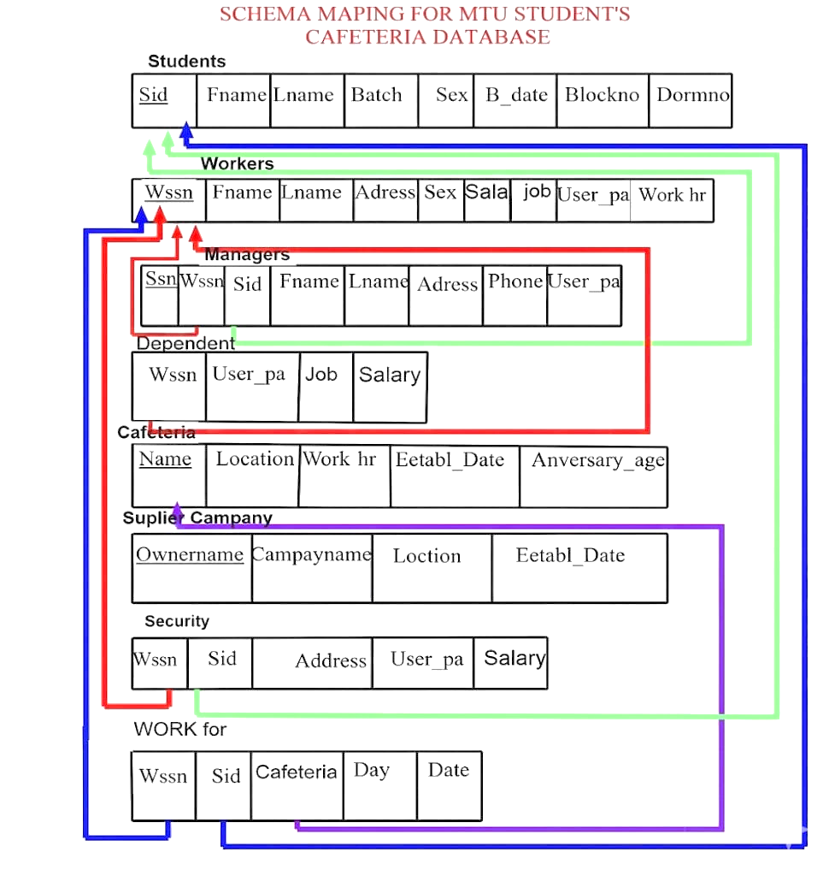

Figure 3 Schema Maping for Students Cafeteria Entity Table

11.NORMALIZATION

Some tables of entity type in our study are not normalized. This means they have a bad relation and data redundancy among them. So in order to avoid those bad relations and redundancy we will normalize those tables as follow.
THE UN NORMALIZED TABLES
Cafeteria Workers
Wssn | Fname | Lname | Address | Sex | Job | Salary | Work_hr
12089  12853  13854  15689  2389 | Meron  Bonsa  Bontu  ABERA  FIREW | Adimasu  Merob  Tola  ADIMASU  GADISA | Bonga  Benchmaj  Sheka  Yeki  Mizan | F  M  M | Coocker  Assistor  Coocker head  Café comitee  Thicker | 2000  200  100  2300  3000 | 8  3  1  8  6

Suplier campany
Owner name | Campany name | Location | Establish_t Date
Alhamudin  Dr,worku | Alhamudinsugarcampany  worku business campany | Adisababa  combolcha  Desie  Mekele | 1967  1980  1990  1923

Manager
Ssn | Wssn | Sid | Fname | Lname | Address | Pho_no | Salary
011  002  003 | 12089,15689,2389  12089,15689,2389  12089,15689,2389 | 166,106,106  166,106,106  166,106,106 | Amanuel  Zeleke  Arhibu | Dergisa  Adene  Mehaba | Tepi  mizan  aman | 0912345676  0923789677  0945345367  0934256778 | 3000  3000  3000

1.FIRST NORMAL FORM (1NF)
Cafeteria Workers
Wssn | Fname | Lname | Address | Sex | Job | Salary | Work_hr
12089 | Mihiret | Feleke | Basa | F | Coocker | 2000 | 8
12089 | Hilina | Tamiru | Benchmaj | F | Assistor | 200 | 3
12089 | Alimaz | Alemu | Benchmaj | F | Coocker head | 100 | 1
15689 | Fetia | Mohamed | Sheka | M | Café comitee | 2300 | 8
2375 | Tebarek | Yeabisira | Bahiru | M | Thicker | 3000 | 6
2389 | Rehima | sayid | Mizan | F | coocker | 200 | 7

Suplier campany
Owner name | Campany name | Location | Establish_t Date
Alhamudin | Alhamudinsugarcampany | Adisababa | 1967
Alhamudin | Alhamudinsugarcampany | Adisababa | 1980
Alhamudin | Alhamudinsugarcampany | combolcha | 1990
Dr,worku | worku business campany | Desie | 1923
Dr,worku | worku business campany | Mekele | 1990

Manager
Ssn | Wssn | Sid | Fname | Lname | Address | Pho_no | Salary
011 | 12089,15689,2389 | 166,106,106 | Amanuel | Abraham | Tepi | 0912345676 | 3000
011 | 12089,15689,2389 | 166,106,106 | Abebe | tasew | Tepi | 0923789675 | 3000
002 | 12089,15689,2389 | 166,106,106 | Cherent | Takele | mizan | 0945345367 | 4000
003 | 12089,15689,2389 | 166,106,106 | Ashenafi | Debeb | aman | 0934256778 | 3100

12.SQL IMPLEMENTATION
/**********DATA BASE CREATION FOR THE CAFETERIA***********************/
drop database mtustuentcafeteria
create database mtustuentcafeteria
use mtustuentcafeteria
drop table student
create table student
(
studId varchar(20) primary key not null,
Fname varchar(20),
Lname varchar(30),
batch int,
sex varchar(2),
B_date int,
Age int,
Block_no int,
Dorm_no int,

)
/*********TABLE CREATION FOR STUDENNT ENTITY**********/
SELECT *FROM student
insert into student values('MTUUR/0021/17','Mihret','Tamene',2,'M',1990,20,334,005);
insert into student values(''MTUUR/0022/17','G/medhin','Abye',2,'M',1987,23,334,003);
insert into student values(''MTUUR/0021/17','Dawit','Mulu',2,'M',1990,20,334,003);
insert into student values('MTUUR/017/09','Adugna','Birhan',2,'M',1990,20,334,002);
insert into student values('MTUUR/226/09','Seyid','Ashebir',2,'M',1992,18,334,006);
insert into student values('MTUUR/260/09','selamawit','Ashenafi',2,'F',1992,18,334,006);
alter table student add studTelNo varchar(20);
alter table student drop column studTelNo;
alter table student add Department varchar(25);
update student set Department='informmation systems';
alter table student drop column Department;
select fName, lName, studId from student;
select fName, lName, studId, sex from student where sex not like 'f';
select fName, lName, studId, sex from student where sex not like 'm';
select fName, lName, studId from student where studId='Scir 166/09';
select fName, Block_no, studId, Dorm_no from student where Block_no='334';
select * from student where fName like 'M%';
select fName,studId from student order by fName ASC;
delete from student where Dorm_no = 005 ;
select SUM(Dorm_no) from Student;
select AVG(Dorm_no) as'average number of dorm number' from student;
select MAX(Dorm_no)as 'maximum numbers of block number' from student;
select min(Dorm_no)as 'minimum number of block number' from student;
select COUNT(*)as 'total number student'from student;
select COUNT(*) as 'number of female students' from Student where sex like 'f';
drop table worker
create table worker
(
Wssn int primary key not null,
Fname varchar(20),
Lname varchar(30),
Adress varchar(30),
sex varchar(2),
Job varchar(20),
SALARY MONEY,
userpass_word varchar(10),
work_hr varchar (20),
)
/*****************************************************/
SELECT *FROM worker
insert into worker values('12089','chaltu','alemu','bonga','F','cooker',2000,'chaltu1208','6 hour');
insert into worker values('15689','bogale','asefa','sheka','M','assistor',2300,'bog2020','4 hour');
insert into worker values('12789','gedisa','frew','mizan','M','cafecomitee',3000,'g2010','3 hour');
insert into worker values('23758','rehima','sayid','tepi','F','cooker',2000,'richo11','5 hour');
insert into worker values('98567','banchu','erku','tepi','F','cooker',2000,'b123','7 hour');
insert into worker values('23445','chaltu','rot','bonga','F','cooker',2000,'c2323','1 hour');
select COUNT(*) as 'TOTAL NUMBER OF FEMALE WORKERS' from worker where sex like 'F';
select COUNT(*) as 'TOTAL NUMBER OF MALE WORKERS' from worker where sex like 'M';
select COUNT(*) as 'TOTAL NUMBERS OF WORKERS' from worker;
drop table manager
create table manager
(
Ssn int primary key not null,
studId varchar(20) foreign key references student(Studid),
Wssn int foreign key references Worker(Wssn),
Fname varchar(20),
Lname varchar(30),
Adress varchar(35),
Pho_no int,
userpass_word varchar(10),
)
SELECT *FROM manager
insert into manager values(001,'Scir 166/09',12089,'chaltu','alemu','bonga',0923415169,'c001');
insert into manager values(002,'MTUUR/106/09',15689,'ozil','saron','tepi',0913417869,'o002');
insert into manager values(003,'MTUUR 250/09',12789,'rati','abere','mizan',0923567805,'r003');
insert into manager values(004,'MTUUR/017/09',23758,'bontu','tola','aman',0934567805,'b004');
insert into manager values(005,'MTUUR/ 226/09',98567,'rose','amirac','bonga',0934557805,'r005');
insert into manager values(006,'MTUUR/260/09',23445,'abokr','amirac','bonga',0934567805,'a006');
/***********************************************************************/
DROP TABLE dependents
create table dependents
(
Wssn int foreign key references Worker(Wssn),
Job varchar(20),
userpass_word varchar(10),
Salary money,

)

/***************************************************************/
SELECT *FROM dependents
insert into dependents values('12089','JANITOR','011A',103);
insert into dependents values('15689','LABOUR','011B',123);
insert into dependents values('12789','FICHER','011RT',150);
insert into dependents values('23758','JANITOR','011R',103);
insert into dependents values('98567','JANITOR','011F',200);
insert into dependents values('23445','TICKER','011F',200);
DROP TABLE cafeteria
create table cafeteria
(
Cafeterianame varchar(50) primary key not null,
Location varchar(50),
Work_hr VARCHAR(10),
Establish_tYear int,
Anversaryage int,
)

SELECT *FROM cafeteria
insert into cafeteria values('MTU TEPI CAMPUS STUDENTS CAFETERIA','TEPI','6 HOUR',1999,11);
insert into cafeteria values('MTU MIZAN CAMPUS STUDENTS CAFETERIA','MIZAN','6 HOUR',1999,11);
insert into cafeteria values('MTU AMAN CAMPUS STUDENTS CAFETERIA','AMAN TOWN','6 HOUR',2009,0);

/***********************************************/
drop table supliercampany
create table supliercampany
(
Ownernamme varchar(40) primary key not null,
Campany_name varchar(60),
Location varchar(50),
Establish_tyear int,
)
SELECT *FROM supliercampany
insert into supliercampany values('Alhamudin','Alhamudin sugar campany','Adisababa',1967);
insert into supliercampany values('Dr worku','worku business campany campany','mekkele',1923);
insert into supliercampany values('ethio geverment','ethio shay campany','combolcha',1967);
insert into supliercampany values('Dr, mihret','mihret food fabrication campany','combolcha',2003);
select Campany_name,Establish_tyear from supliercampany order by Establish_tyear ASC;
select *from supliercampany where Location = 'combolcha' ;
select *from supliercampany where Establish_tyear>=2000;
select Campany_name as 'SUPLIER CAMPANY IN ADIS ABABA' from supliercampany where Location = 'Adisababa' ;
/*********************************************/
DROP TABLE securityy
create table securityy
(
Wssn int,
Studid int,
Adress varchar(30),
userpass_word varchar(10),
Salary money,

)

SELECT *FROM securityy
insert into securityy values(123,166,'TEPI','1043',1990);
insert into securityy values(234,106,'TEPI','2323',2090);
insert into securityy values(189,250,'TEPI','1010',200);
insert into securityy values(12,226,'TEPI','102',1000);
drop table fooddescription
create table fooddescription
(
datee varchar(30),
dayy varchar(12),
Breakfast varchar(20),
lunch varchar(23),
Dinner varchar(28),
Cost money,
)

SELECT *FROM fooddescription
insert into fooddescription values('january 11,02,2025Gc','Monday','Rooz with dabo','injera','injera',15);
insert into fooddescription values('january 12,02,2025Gc','Tusday','Dabo with tea','pasta','injera',14);
insert into fooddescription values('january 13,02,2025Gc','Wednsday','Firfir','injera','zerfore',26);
insert into fooddescription values('january 14,02,2025Gc','Thursday','mekoreni','injera','injera',13);
insert into fooddescription values('january 15,02,2025Gc','friday','firfir','injera','zerfore',31);
select datee,dayy from fooddescription where Breakfast='Firfir';
select *from fooddescription where Dinner='zerfore';
select dayy as 'day with maximum food purchase cost' from fooddescription where Cost>=25;
select SUM(Cost) as 'sum of costsharing for one student per 5 conscutive day in Etbirr' from fooddescription;
select AVG(Cost) as'average cost of food' from fooddescription;
select MAX(Cost)as 'maximum cost of food in the cafateria' from fooddescription;
select min(Cost)as 'minimum cost of food in the cafateria' from fooddescription;
select COUNT(*)as 'Zerefore day per week'from fooddescription where Dinner='zerfore';
select COUNT(*) as 'firfir break fast per a week ' from fooddescription where breakfast='firfir';
drop table WORKFOR
create table WORKFOR
(
Cafeteria varchar(50),
Sidd varchar(20) foreign key references student(Studid),
Wssn int foreign key references Worker(Wssn),
dayy varchar(23),
datee varchar(25),
)
SELECT *FROM WORKFOR
insert into WORKFOR values('MTU TEPI CAMPUS STUDENTS CAFETERIA','Scir 166/09',12089,'Monday','11/01/2025 Gc');
insert into WORKFOR values('MTU MIZAN CAMPUS STUDENTS CAFETERIA','Scir 106/09',15689,'Tuesday','12/01/2025 Gc');
insert into WORKFOR values('MTU AMAN CAMPUS STUDENTS CAFETERIA','Scir 250/09',12789,'Wednsday','13/01/2025 Gc');
insert into WORKFOR values('MTU TEPI CAMPUS STUDENTS CAFETERIA','Scir 017/09',23758,'Thursday','14/01/2025 Gc');
insert into WORKFOR values('MTU MIZAN CAMPUS STUDENTS CAFETERIA','Scir 226/09',98567,'Fiday','15/01/2025 Gc');
insert into WORKFOR values('MTU AMAN CAMPUS STUDENTS CAFETERIA','Scir 260/09',23445,'Saturday','11/01/2025 Gc');

/**********************************************************************************************************************************************************************/
/*TO VEIW THE WHOLE CAFETERIA DATBASE PLEASE EXCUTE THE ABOVE QUERY ONE BY ONE AND THEN SELECT ALL THE QUERY BELLOW ONCE THE EXCUTE AND DRAG DOWN TO VIEW ALL DETAILS*/
/** COMMENT LINE IS NOTHING TO EXCUTE **/
/**/SELECT studId,Fname,Lname,batch,sex,B_date,Age,Block_no,Dorm_no as '%%%%%%%%%%STUDENT TABLE drag down to view more!!!%%%%%%%%' from student /**/
/**/select Wssn,Fname,Lname,Adress,sex,Job,SALARY,userpass_word,work_hr as '%%%%%%%WORKERS TABLE%%%%%%%' from worker /**/
/**/select Ssn,studId,Wssn,Fname,Lname,Adress,Pho_no,userpass_word as '%%%%%%%MANAGERS TABLE%%%%%%%' from manager /**/
/**/select Wssn,Job,userpass_word,Salary as '%%%%%%%DEPENDENTS TABLE%%%%%%%' from dependents /**/
/**/select Cafeterianame,Location,Work_hr,Establish_tYear,Anversaryage as '%%%%%%%%%%CAFETERIA TABLE drag down to view more!!!%%%%%%%%' from cafeteria /**/
/**/SELECT Ownernamme ,Campany_name,Location,Establish_tyear as '%%%%%%%%%%SUPLIER CAMPANY TABLE drag down to view more!!!%%%%%%%%' from supliercampany /**/
/**/SELECT Wssn,Studid,Adress,userpass_word,Salary as '%%%%%%%%%%SECURITY TABLE drag down to view more!!!%%%%%%%%' from securityy /**/
/**/SELECT datee,dayy,Breakfast,lunch,Dinner,Cost as '%%%%%%%%%%FOOD SHEDULE TABLE drag down to view more!!!%%%%%%%%' from fooddescription /**/
/**/select Cafeteria,Sidd,Wssn,dayy,datee as '%%%%%%%%%%TABLE THE RELETION WORK FOR Now you already reach at the eand of the veiw!!!%%%%%%%%' from WORKFOR /**/
/**/ /**/
/**********************************************************************************************************************************************************************/

/********************THE END *****************/
/********************TANK YOU*****************/

